Sound-Based Creativity in Schools

This document provides an outline for 3 workshops to be used in schools for introducing pupils to sound-based creativity. They are each designed for 1-hour lessons, but it is intended that they should be adaptable for different circumstances, meaning that exercises can be reduced or extended depending on the time available.

Workshop 1 – Listening Training

Tags: #Listening #Sound-based music #Soundwalk #Soundscape #Soundscape composition #Hildegard Westerkamp #Acoustic ecology #Sound parameters

The first session will focus on listening. Through participating in this workshop the pupils will:

- Begin to open their ears to the sounds around them through simple listening exercises.
- Be introduced to the concept of making music using sounds.
- Understand how listening practice can be a source of inspiration for creating sound-based music.
- Engage in focused listening to environmental sounds by participating in a soundwalk in the local area.
- Discuss and reflect on the sounds encountered during the walk and their different characteristics.

Short introduction – concerning listening. This will introduce the pupils to the workshops and the idea of learning to listen attentively. It can be suggested that this is a valuable but difficult skill to learn to do well.

Gong listening in the classroom
Take a resonant instrument that has a long decay (a gong, suspended cymbal, triangle). Ask the group to close their eyes and listen to how long the sound lasts when played and, when they hear the sound stop, to open their eyes or put their hand up to indicate they can't hear it anymore.
Ask the class:
Q: Is it clear when the gong sound ends?

Do this several times now asking the group to remember what other sounds they heard just before they opened their eyes.

After listening, each pupil will create their own listening list on paper following which the class will collaboratively produce an overall list of all the sounds heard.

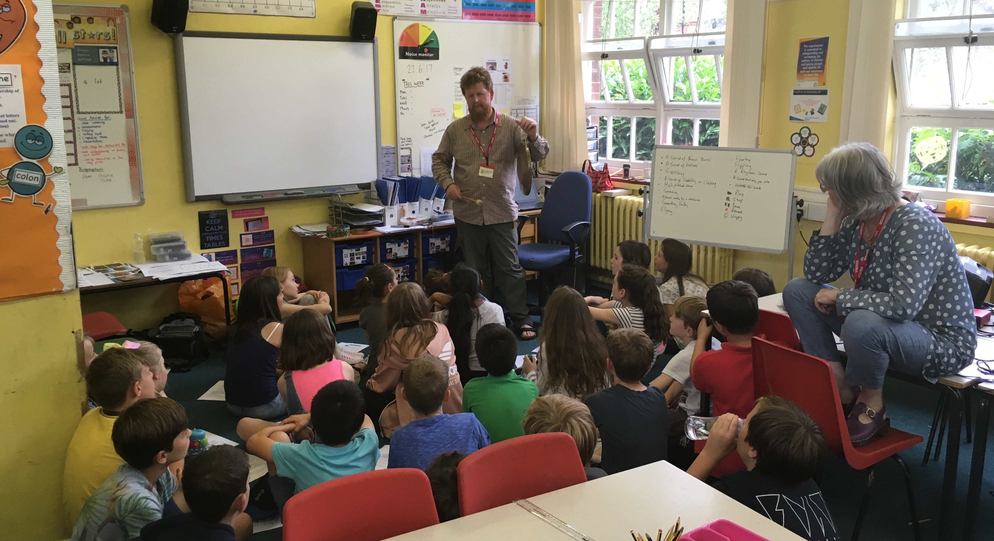

Soundwalk

A soundwalk is where a group (or a single person) walk quietly through a chosen area listening closely to the sounds around them. This will be conducted around the school grounds and through the school itself. The soundwalk leader will record the soundwalk (there might be interesting sounds that can be played back to the pupils or used later in creative work) and it should last approximately 10 minutes. Beforehand the pupils will be given a soundwalk instruction sheet (see next page). This facilitates a more focused listening than the classroom exercises and it encourages children to think about sound characteristics (such as pitch, duration and volume).

Soundwalk Instruction Sheet

What do you hear?

Lead your ears away from these sounds and listen beyond .... into the distance
What else do you hear?
What else?
What else?
Which sounds are the LOUDEST?

Which are the quietest?

Which sounds are short? - -
Which sounds are long?

Are HIGH
they or in
LOW pitch?

Which sounds would you keep?

Which sounds would you scrap?

Discussion
There will be a discussion immediately after the soundwalk about what was heard, where the sounds were heard and which sounds were liked and disliked. Additionally, the sounds can be identified in relation to their particular characteristics such as amplitude, pitch or duration.

This discussion can also be used to help explain that you can listen to the sounds for their music qualities (such as pitch or duration) or for their context (what is the source of the sound).

To finish – play excerpt of ‘Cricket Voice’ by Hildegard Westerkamp.

Before playing –

- Explain that some composers go on soundwalks in particular places to get inspiration for making sound-based music, which is music that uses sounds rather than notes.

- Also encourage them to listen to it both in a musical and contextual way.

- Don’t tell them the title of the piece and ask the class if they can tell what sounds Westerkamp used for the piece.

- Does the piece make them think of a particular environment? (It was recorded in a desert in Mexico)

- Can they hear different pitches and rhythms? (Westerkamp has made rhythms out of the cricket sounds and changed their pitch).

Workshop 2 – Recording Treasure Hunt

Tags: #Recording #Microphones #Digital recorders #Listening #Sound type #Sound source #Recording techniques #Composition

This session focuses on collecting sounds and how they can be categorised in different ways. Through participating in this workshop the pupils will:

- Discover strategies for finding and recording interesting sounds
- Understand some of the ways in which these can be organised
- Develop the listening skills from the first workshop.

Introduction
Talk about what sounds they heard from the listening exercise in session 1 and give a recap on the objectives of the workshops. Explain that in this session they will be collecting sounds to use in their compositions.

Play ‘Everything but the Kitchen sink’ by Duncan Chapman.

Ask what types of sounds did Duncan use in this composition? Highlight the quieter/slower section where the pan sounds have been transformed into resonant tones.

Then explain that they will be recording sounds to use in their compositions and that they need to first think about what types of sounds to collect.

What to record? Some strategies for collecting interesting sounds

If you simply give a group of students a recording machine and send them to collect sounds they are likely to return with mostly recordings of themselves. Establishing WHAT they are going to record is vital.

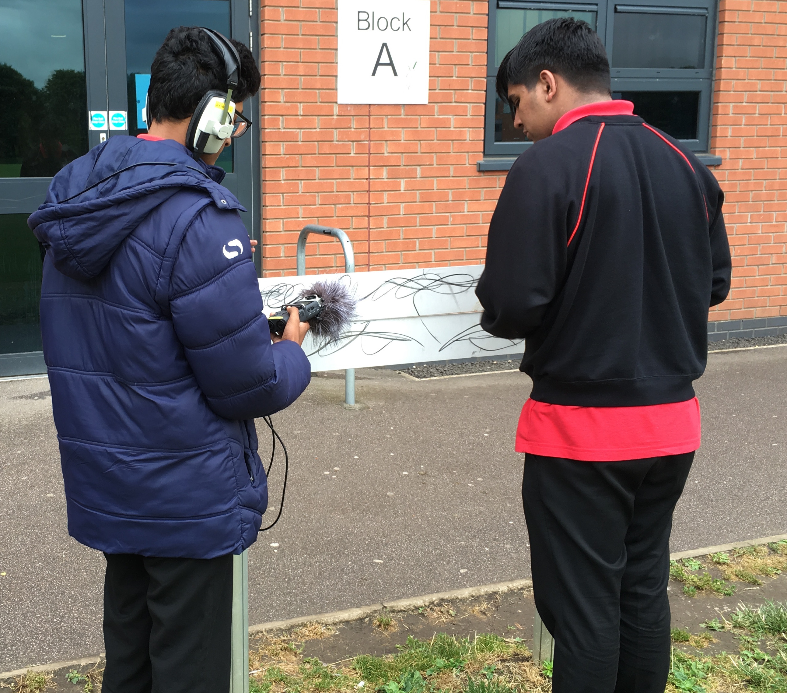

Treasure hunt
One way of organising the collecting of sounds is to have a sonic treasure hunt. This involves creating different kinds of lists of sounds to find. Explain that they could create a list that is very prescriptive and identifies exactly what they are going to record. Or, more interestingly, they could create an open and imaginative list that can be interpreted in different ways. For example, "a sound made by a machine" is often going to result in a more interesting and diverse range of sounds than "the sound of a car".

Create a list of this type together with suggestions from the class, below are some ideas you could add to this:

• A sound made by a machine • A sound made by travelling from inside to outside • A sound made by a non-human animal • A sound made by someone you know • A sound made by dropping something • A sound made by food • A sound made by a musical instrument • A sound that makes you think of the sea • A sound made by the weather • A hidden sound that no one has heard before • A quiet sound • A loud sound • A sound which repeats • A sound which is randomly changing • A sound that gets louder • A sound that gets quieter • A short sound • A long sound • A continuous sound • A high sound• A low sound

Demonstrate how to use recording device

Before dividing the class into groups, demonstrate how the recording device works and make a recording of the whole class saying a word (e.g. ‘listen) that you then play back to them.

Recording
1. Divide the class into groups (this will depend on the number of recorders available and the class size but the smaller the groups the better).
2. Equip each group with a recording device, pair of headphones, recording log sheet and something to write with.

3. Starting in the classroom make some test recordings so that each group are clear about how their machine works and how to play back the sound that they have just recorded.

4. After making tests recordings ask each group to make a list of the types of sounds (taken from the list made by the whole class, which they can add to) they want to collect BEFORE going on their recording trip.

Also ask the class:
Q: Are they going to record the sounds of a place without intervention in making the sounds?
OR
Q: Are they going to record sounds of what they do with what they find i.e. sounds that they are actively playing?

An effective strategy is to start with listening to the sounds that are in the environment already. This avoids the tendency for the children to go around hitting things. However, you could gradually introduce the idea of the children playing things e.g. if you find yourself by a pond on a gravel path then it would be daft NOT to drop a few stones in or shuffle your feet etc

5. Ask each group to make a log of the sounds they record AS they do it (this is the part that pupils often neglect but it's important to try and have a written record of the sequence of the recorded sounds so that they will be easily able to find them when they come to use them in composition).

6. Get the children to take turns to use the recording device and make the recording log.

7. After making test recordings for a short time give the groups a clear time limit and idea of where they CAN go to make recordings in a wider area (playground, other classes, hallways, office etc).

Final exercise – listening back and reflection
If there is time, when all the groups have collected the sounds you might want to have a sharing of what has been collected.

A way of doing this is to:
1: Ask each group to choose their favourite sound from the ones they have collected. Play these back one at a time and talk about them maybe using the questions from the Soundwalk session.

2: Ask each group to choose a sound they have recorded where it is unclear what the source is. Play these back one at a time and discuss the characteristics of the sounds (you will need to prime the group to make sure they keep the source a secret). This can be a good way of talking about the details rather than the names of sounds.
Workshop 3 – Composing

Tags: #Composition #Audio software #Audio processing #Audio editing #Musical parameters #Experimentation #Sequencing #Transformation #Loops

This session focuses on listening to the sounds recorded in workshop 2 and begin to compose pieces using those sounds. This workshop will require the pupils to use software in which sounds can be arranged, edited and manipulated (such as Soundplant, Compose with Sounds or Audacity). Through participating in this workshop the pupils will:

- Further develop listening and describing skills from workshops 1 & 2
- Learn to use software to edit, manipulate and transform sounds.
- Begin to arrange the sounds into compositions.

Introduction
Play some of the sounds that were recorded in the previous session and then import these into the software. Give a basic introduction to how the software works. Demonstrate how sounds can be edited, looped and transformed.

Activity 1 – learning to use the software through experimentation
Allow the pupils some time to experiment with the software and sounds for them to get used to how it works. Check that they have all managed to use the basic functions successfully and then move onto

Activity 2 - Composing with Sounds
Explain that they now need to start to organise their sounds into compositions. To illustrate how this can be done refer to the example pieces played in previous weeks and then play:

"C'est Wizzz!!!" by Florian Sulpice
Explain that this piece was created by a school pupil in France. Ask how the piece can be described? Can the metaphor of a journey be used to describe its development? How are the materials arranged? Highlight the contrast between short dry sounds and longer sustained sounds with reverberation.

Then, before asking the children to start work on their own pieces, give the pupils some simple tips for composing, such as:

- Which sound or sounds will start the composition?
- How do the individual sounds start and end? Fade in or suddenly appear?
- Will some sounds repeat? Will there be certain motif sounds?
- How many sounds play at once? How could this be shown in the score?
- Contrast – this can be a useful compositional tool. For example, the contrast between long and short sounds or quiet and loud sounds, which leads onto….
- Dynamics - explain what this means. Are there any sounds that they have recorded that might help them to achieve this?
- How will the piece end?
- Create plans or scores for organising their compositions. How will the different sounds be sequenced?

Ask the children to first listen to the sounds they have available and then start to select the sounds that they want to work with. To do this they need to think about which sounds will work well together. Encourage them to use a good balance of similar and contrasting sound types.

At the end of the workshop make sure all the compositions are saved in a place that will be easily accessible in the next workshop. It is a good idea to save the work to a memory stick to avoid problems in the next session.

IF there is time at the end of the workshop share some of the most promising work with the rest of the class and highlight the best aspects.

Workshop 4 – Composing/finishing

Tags: #Composition #Audio processing #Audio editing #Sequencing
#Feedback #Evaluation #Listening

This is the final workshop in which pupils will finish their compositions and share them with the rest of their class. Through participating in this workshop the pupils will:

- Structure, evaluate, revise and complete compositions
- Give feedback and comment on other pupils work
- Complete a questionnaire about their responses to a sound-based piece of music.

In this session the children need to complete their compositions. Start the session with a brief reminder of what the pupils did in the previous session and how the software works. Remind them about the tips for composing that were outlined in the previous workshop.

In this workshop the children need to evaluate their work. Encourage them to think about which aspects of their pieces work well and how they can make changes to improve on what they have already done. Set a clear time limit (around 30 minutes) for them to finish their compositions and save their work.

If time allows, play their work to the rest of the class. Ask the children to make comments on what they like about the different pieces.

For the final 15 minutes - complete Intention/Reception questionnaires in response to "Passing through” by Katerina Tzedaki (see http://cws.dmu.ac.uk/EN/10). First read out and discuss the information provided by the composer taken from the Compose with Sounds site (http://cws.dmu.ac.uk/EN/24). Following this play the piece and then ask the pupils to complete the questionnaires. Explain that this is not a test, there are no right or wrong answers, and that the questionnaires should be completed individually without discussion.

Further listening:

A number of examples of sound-based repertoire can be found at the EARS 2 listening room:
http://ears2.dmu.ac.uk/category/listen/listening-room/

All the pieces created as part of the Compose with Sounds project can be found here:
http://cws.dmu.ac.uk/EN/10

A number of artists who specialise in field recordings release material through the Touch label, examples of this can be found here:
http://touchradio.org.uk

Further information on Hildegard Westerkamp compositions can be found here:
http://www.sfu.ca/~westerka/compositions.html#comp

More pieces by Katerina Tzedaki can be heard here:

https://tzedk.wordpress.com/music/

A selection of Duncan Chapman sound recordings can be found here:
http://www.duncanchapman.org/sound-of-the-week/

Useful links

EARS 2 website - http://ears2.dmu.ac.uk

World forum for acoustic ecology - http://wfae.net

